SMART WEATHER

APP DEVELOPMENT

(WITH JIRA)

JIRA SNAPSHOTS

Contents

Dashboard 3

EPICS 3

Story 4

SPRINTS 5

SCRUM Sprin 1 5

SCRUM Sprint 2 6

SCRUM Sprint 3 6

Timeplan 7

Dependencies 8

Burnup chart 9

Velocity Report 10

Cumulative flow diagram 11

Release and Version Plan 11

Project Pages 13

Code 13

Roadmap 14

Source code repositories. 15

GitHub 15

Confluence 15

# Dashboard

# EPICS

# Story

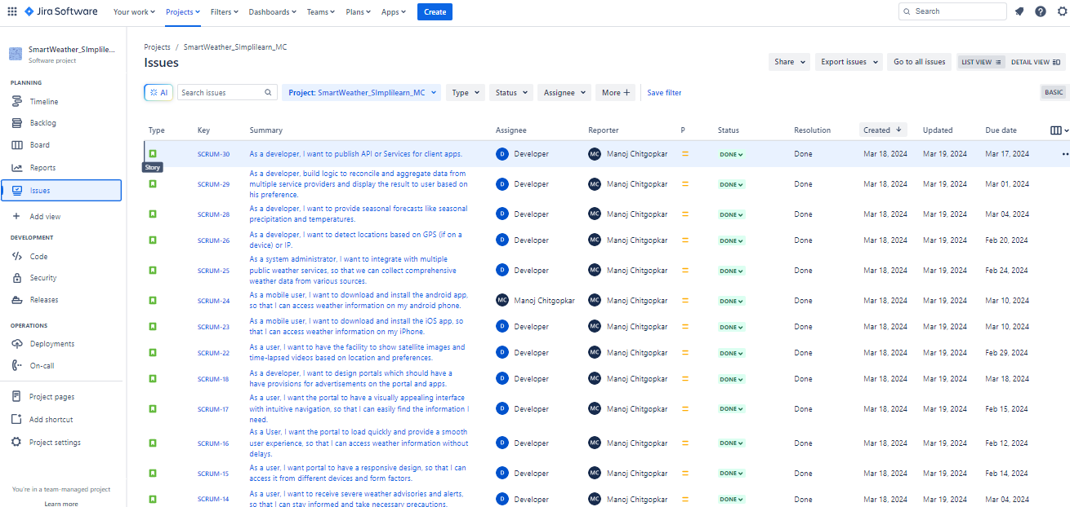

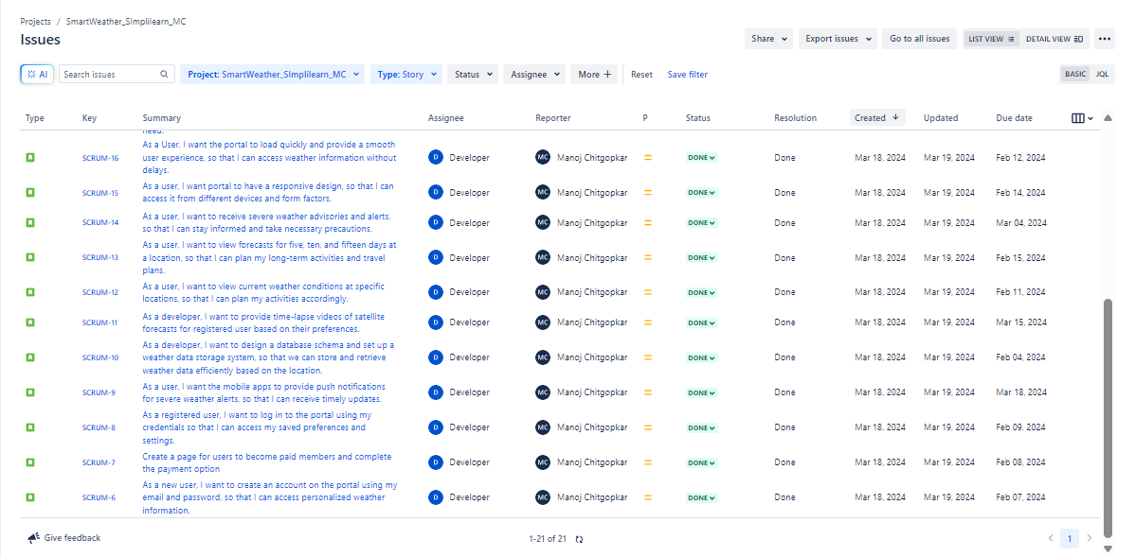

# SPRINTS



## SCRUM Sprin 1

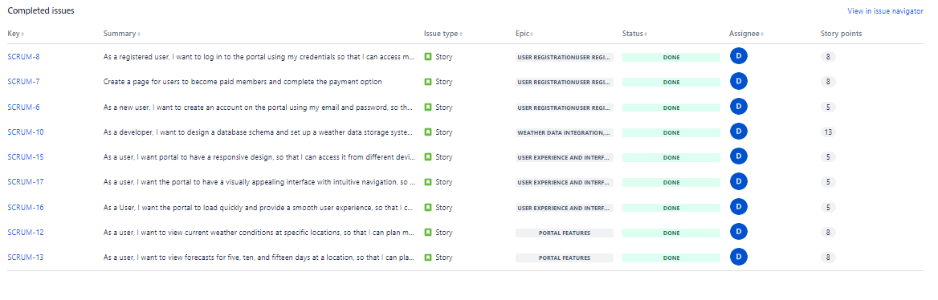

## SCRUM Sprint 2

## SCRUM Sprint 3

# Timeplan

# Dependencies

# Burnup chart

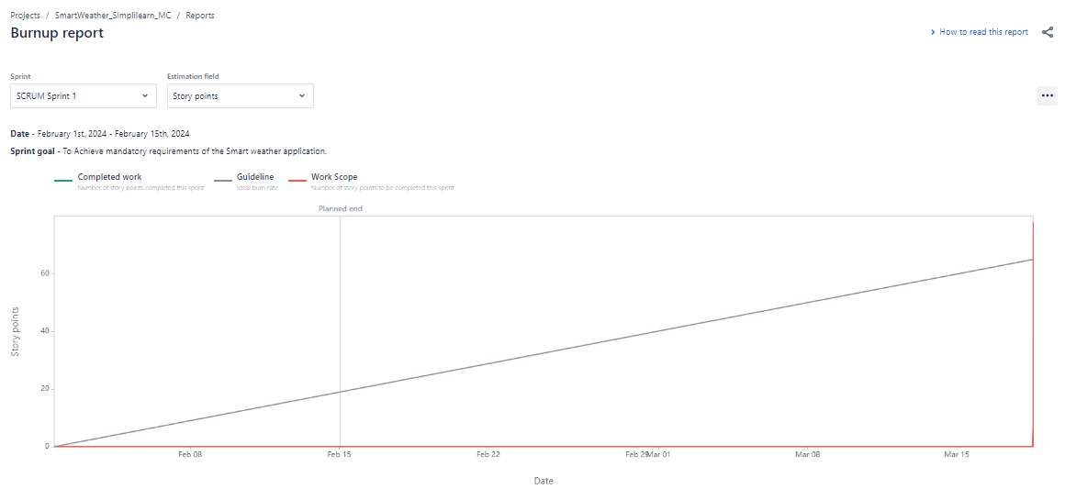

# Velocity Report

# Cumulative flow diagram

# Release and Version Plan

# Project Pages

# Code

# Roadmap

# Source code repositories.

## GitHub

## Confluence

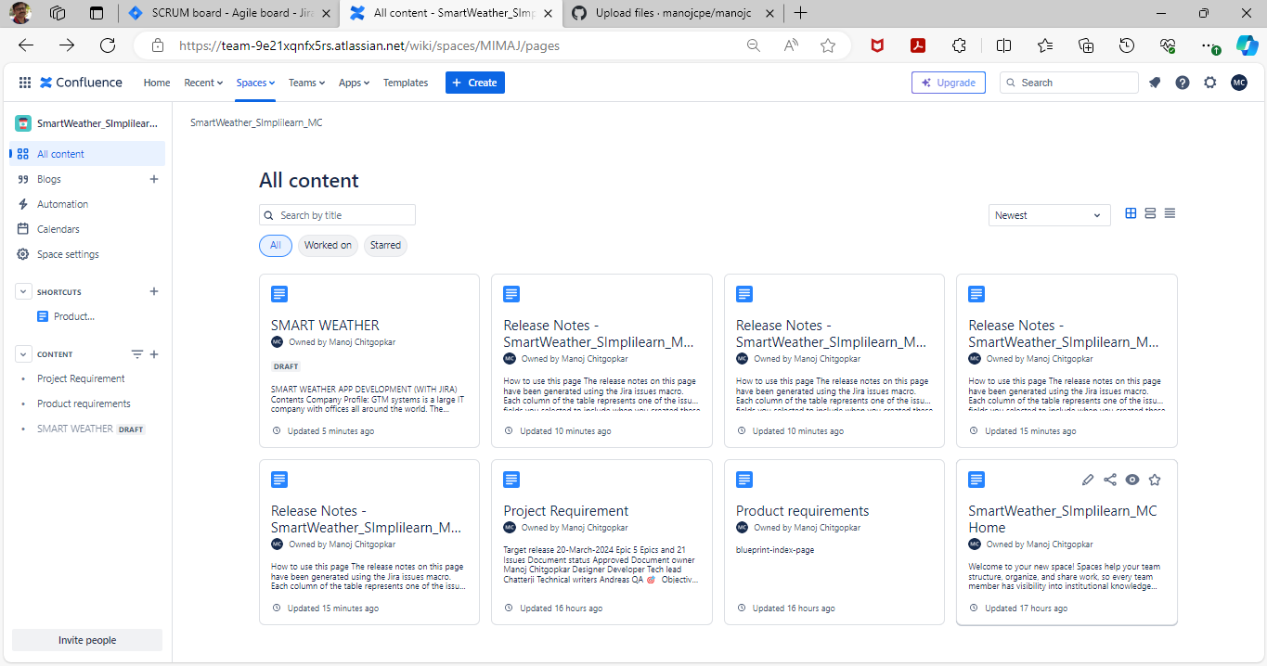

THANK YOU